CLI Hands on

<https://aws.amazon.com/cli/>

Commands we used here are aws --version , aws configure, aws help.

Go to this URL ans select the windows one to install.

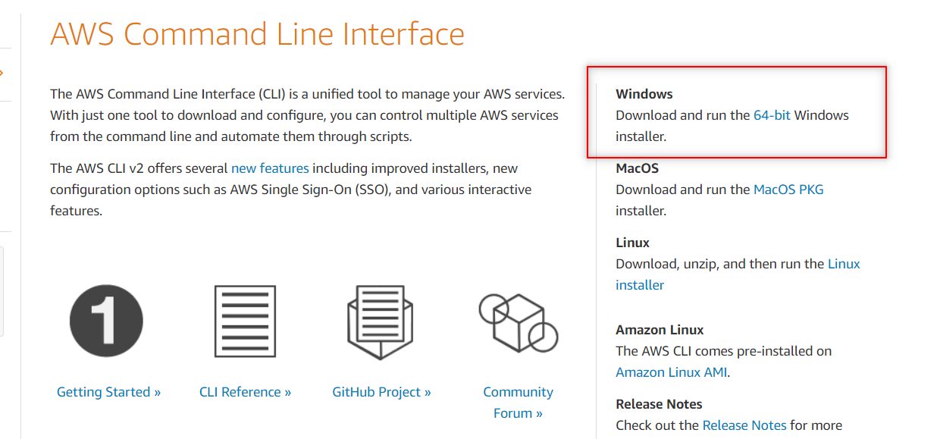

The exe file will get to download click on next don’t do any changes just click on next to install the downloaded file. You can see it in download part.

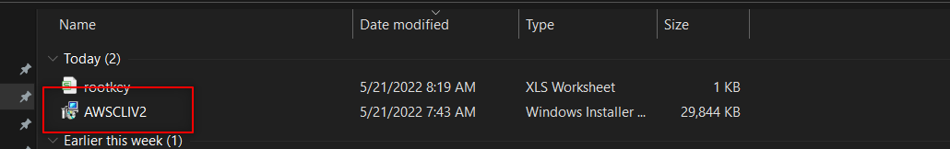

Open CMD in search bar ,the command prompt will open.

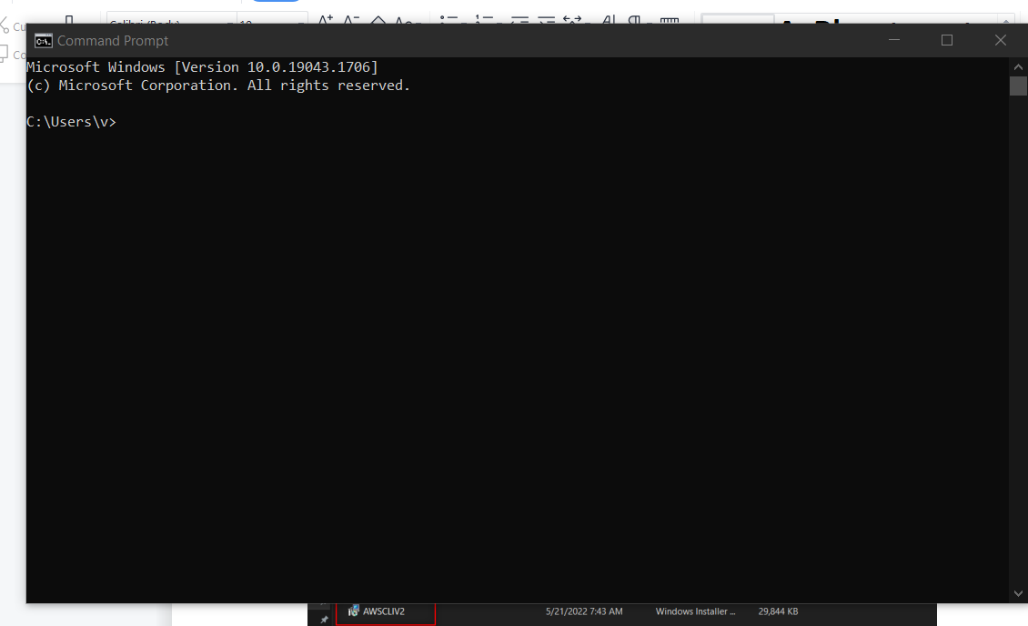

Now enter **aws --version** to see the version of CLI.

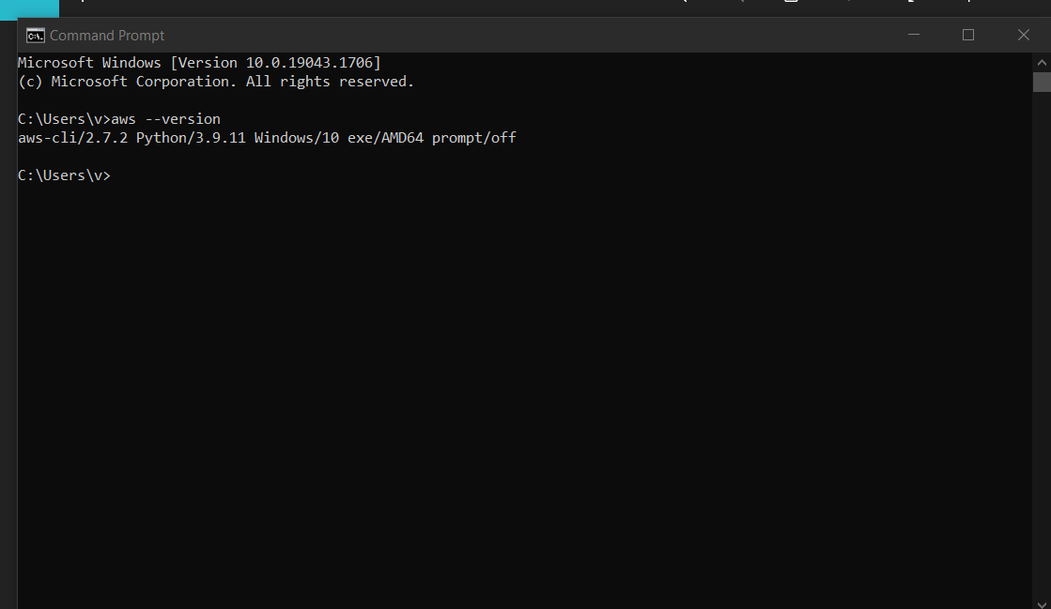

Go to AWS account , Top right corner ,your user name will be displayed , click on that and click on Security Credentials.

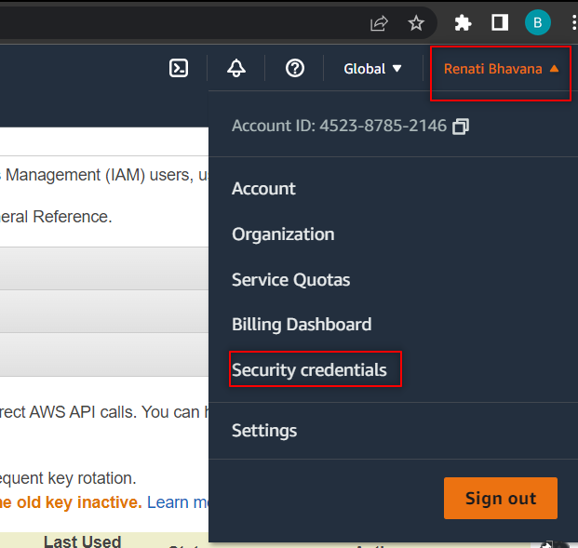

Click on that go to Access keys , under this Click on Create New Access Key and click on Download .The Access key ID and Secrete Key ID will get downloaded to excel file.

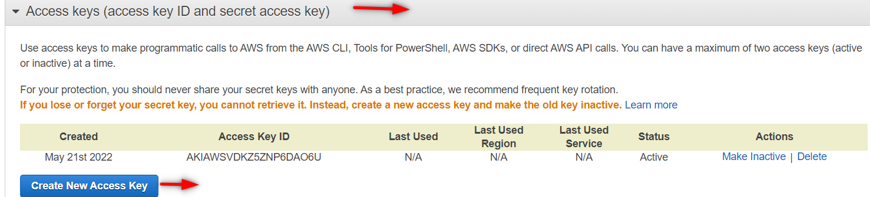

You can see below the downloaded excel file with Access key and secrete Key ID.

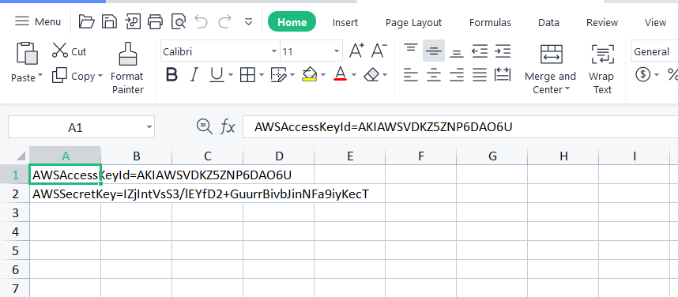

Now Go to CMD and enter **aws configure** and it will ask **ACCESS KEY ID ,** paste the AK ID that u have downloaded . and click on enter and it will ask **SECRETE KEY ID,** paste it and click on enter**.**

It will ask **Default Region name , Go to aws and select any region and paste it in CMD(ap-notheast-1).a**nd click on enter. It will ask **Default Output Format ,** enter **text** and click on enter**.** As shown in below.

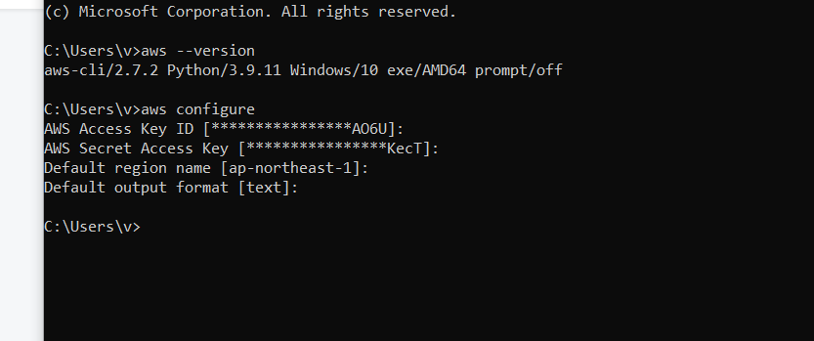

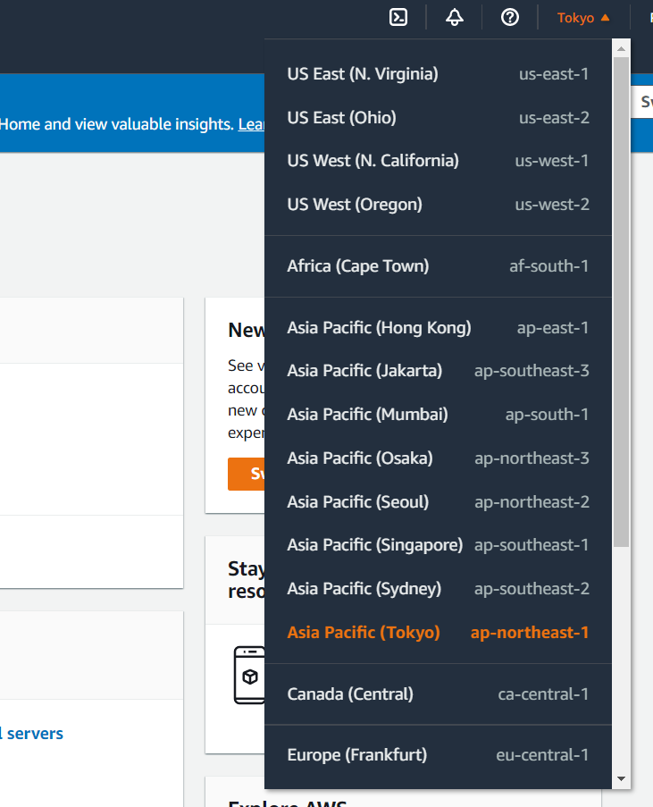

After clicking on enter provide **aws help** it shows like below.

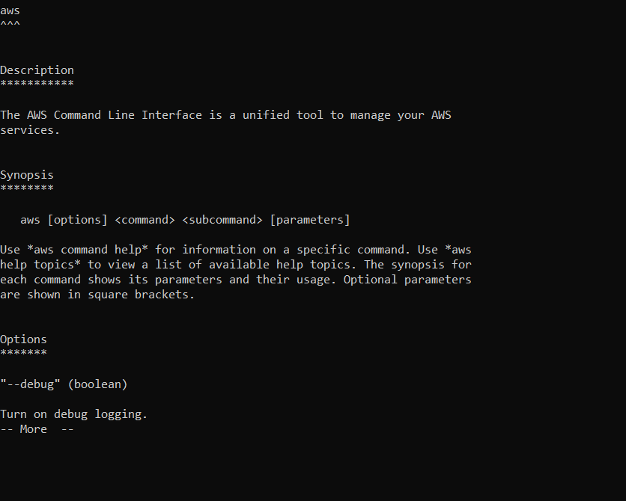

Same like this you can execute different commands over here and you can see that commands in aws CLI documentation……